HOTEL BOOKING ANALYSIS

**Problem Statement:**

Resort hotel and City Hotel group have multiple properties all over the world. They are a popular chain will lots of bookings, however they are now seeing a hike a room cancellation rate. This leads to multiple issues like fewer revenues and less than ideal hotel room use. We need to analyze and find out the probable reasons for cancellation, the trends seen and suggest remedial steps to improve their revenue.



**Assumptions:**

1. No unusual occurrences between 2015 and 2017 will have a substantial impact on the data used
2. The information is still current and can be used to hotels’ possible future plans in an efficient manner.
3. The are no unanticipated negatives to the hotel employing any suggested technique.
4. The hotels are not currently using any of the suggested solutions.
5. The biggest factor affecting the effectiveness of earning income in booking cancellations.
6. Cancellations result in vacant rooms for the booked length.

**Findings and Analysis:**

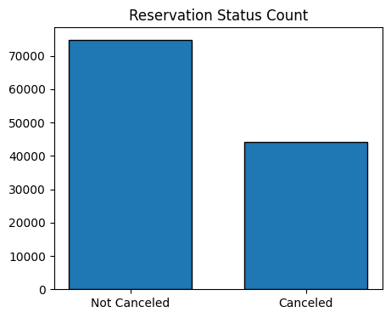

The above graph shows the percentage of reservations that are cancelled and those that are not. We found out that almost 37% of rooms booked end up getting cancelled, which is making the hotels loose revenue and making it difficult to maintain the empty rooms (incur extra expenses)

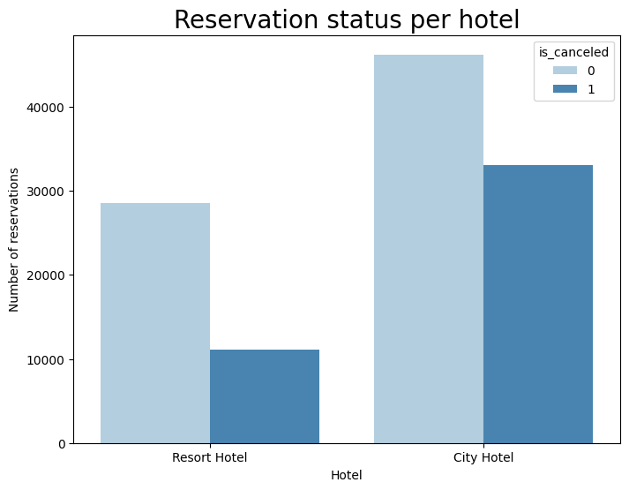

Upon further analysis of cancellations in individual hotels, we see that Resort Hotel has fewer bookings compared to City Hotel but the rate of cancellation is also much lower. City Hotel rooms are booked more frequently; however, the rate of cancellation is also extremely high – almost 70% rooms booked are getting cancelled. Here it is possible that Resort Hotels are more expensive compared to City Hotels. But to be sure, we compared the Average Daily Rates of both Hotels.

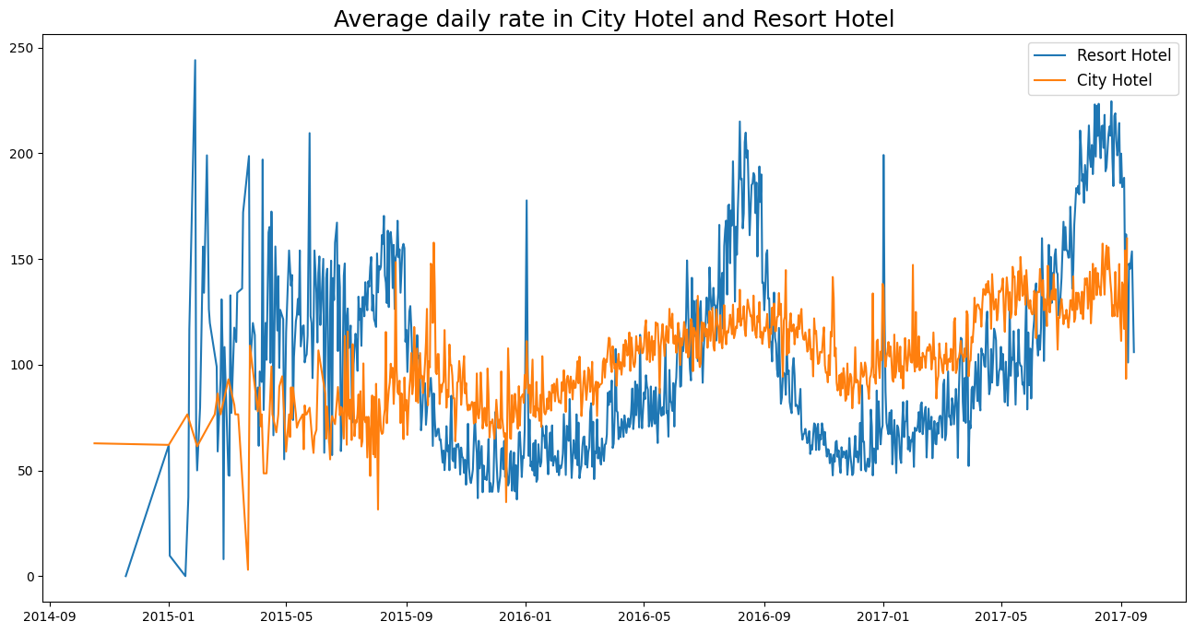

The above line graph shows that the average rate for City Hotel is less than that of Resort Hotel for most of the days. The spikes seen in data show that the rate varies on weekends/holiday seasons. To find out more about the trends in cancellation, we have plotted a group bar graph to analyze the months with the highest and lowest reservation levels according to the reservation status.

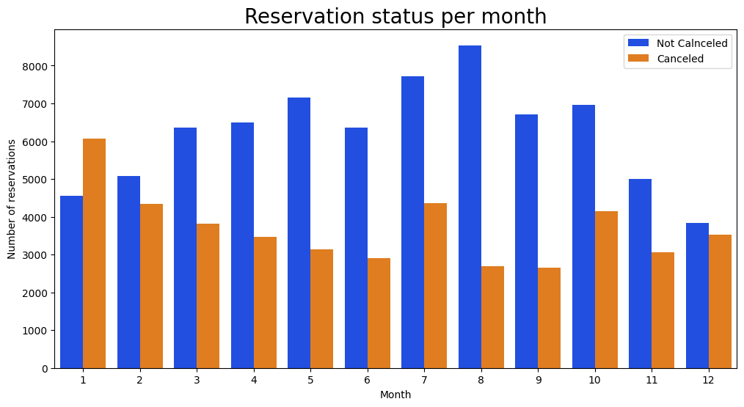

Our analysis shows that the highest number of reservations were done in August. The least number of cancellations were in also in August whereas maximum reservations were cancelled in January (more than 50% bookings cancelled). This may have a correlation with the room prices in different seasons/months. So, we plotted a bar graph comparing Average Daily Rates of different months.

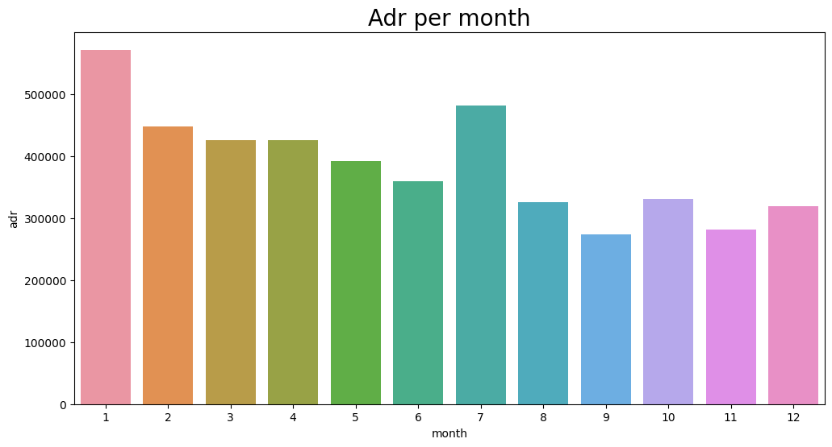

The above graph clearly shows that the room prices are the highest in January and lowest in August. So, we can conclude that the cancellations are most common when prices are highest and are least common when prices are lowest. Therefore, the cost of accommodation is solely responsible for the cancellation.

Next, we moved on to find out which countries have the maximum cancellations and observed that almost 70% of rooms booked in Portugal are getting cancelled.

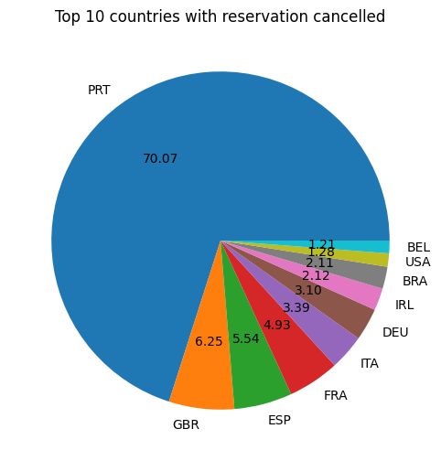

We also worked around the market segments which help generate the reservations. Our analysis showed that almost 47% of reservations are made through Online Travel Agents and about 20% are made through Offline Travel Agents. Only 10% reservations are done by directly visiting the hotels.

For cancellations also, almost 46% reservations coming from online channels are cancelled while 27% reservations coming from groups are cancelled.

Our last plot, shows the average daily rates for rooms that are cancelled and those that are not cancelled. This clearly shows that reservations are cancelled when the prices are higher. Its proves to us that higher prices lead to higher cancellation.

**Suggestions:**

1. Cancellation rates rise as the prices rise. In order to prevent cancellations, hotels could work on their pricing strategies and try to lower the rates for specific hotels based on locations.
2. As ratio of cancellation is higher for Resort Hotel compared to City Hotel, the Resort Hotels could provide reasonable discount on room prices on weekends or holidays.
3. Hotels can work on their marketing campaigns for January with a reasonable amount and come up with special offers/packages to increase revenue as cancellation is highest in this month.
4. They can improve the quality of hotels and services mainly in Portugal to reduce the cancellation rates in the country.